**Group Project Documentation   
 Software Architecture and Design**

***Mentor Booking Platform***

**Prepared by Group 5**

***Trịnh Nhật Huy – SE170480  
Nguyễn Văn Vinh – SE172166  
Bùi Bảo Ngọc - SE173386  
Cao Thuý Liễu – SE172847  
Nguyễn Lê Minh Dũng – SE170490***

**Ho Chi Minh City, 2024**

**Table of Contents**

Contents

**I.** **ERD Conceptual** 1

**II.** **ERD Logical** 2

**III.** **ERD Physical** 3

**IV.** **Usecase Diagram** 4

**V.** **System Overview Diagram** 5

**VI.** **Activity Diagram** 5

**VII.** **Sequence Diagram** 6

**VIII.** **State Diagram** 7

**Revision History**

|  |  |  |  |
| --- | --- | --- | --- |
| **Name** | **Date** | **Reason For Changes** | **Version** |
| *Minh Dung* | *06 November 2024* | *Initial draft* | *1.0* |
| *Minh Dung* | *11 November 2024* | *Done* | *2.0* |

# **ERD Conceptual**

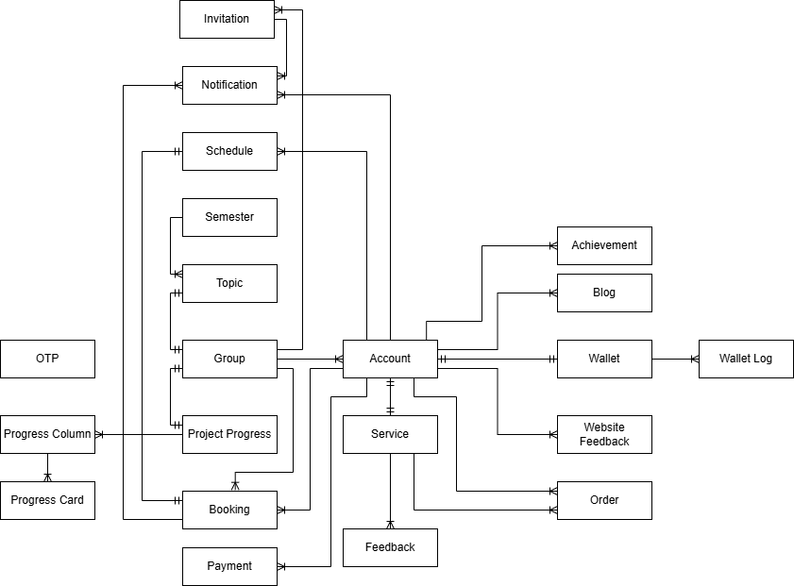

# **ERD Logical**

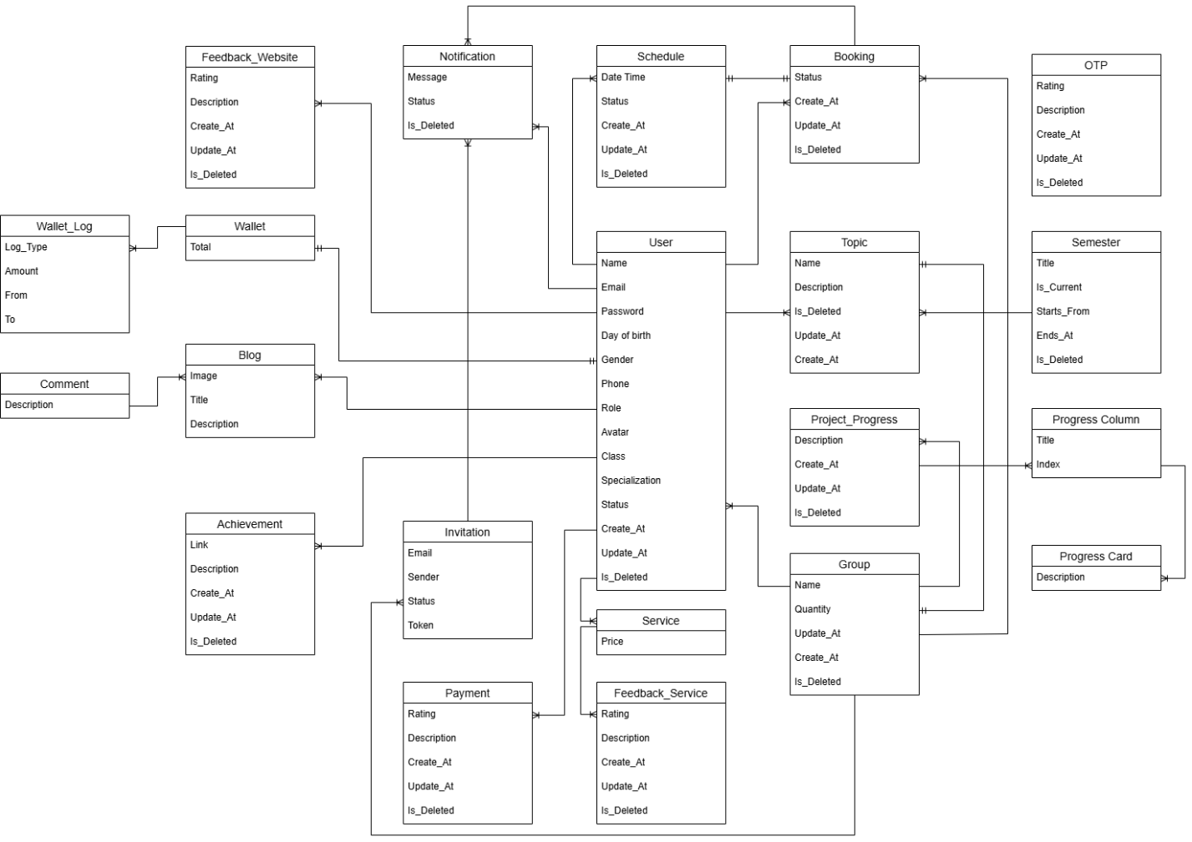

# **ERD Physical**

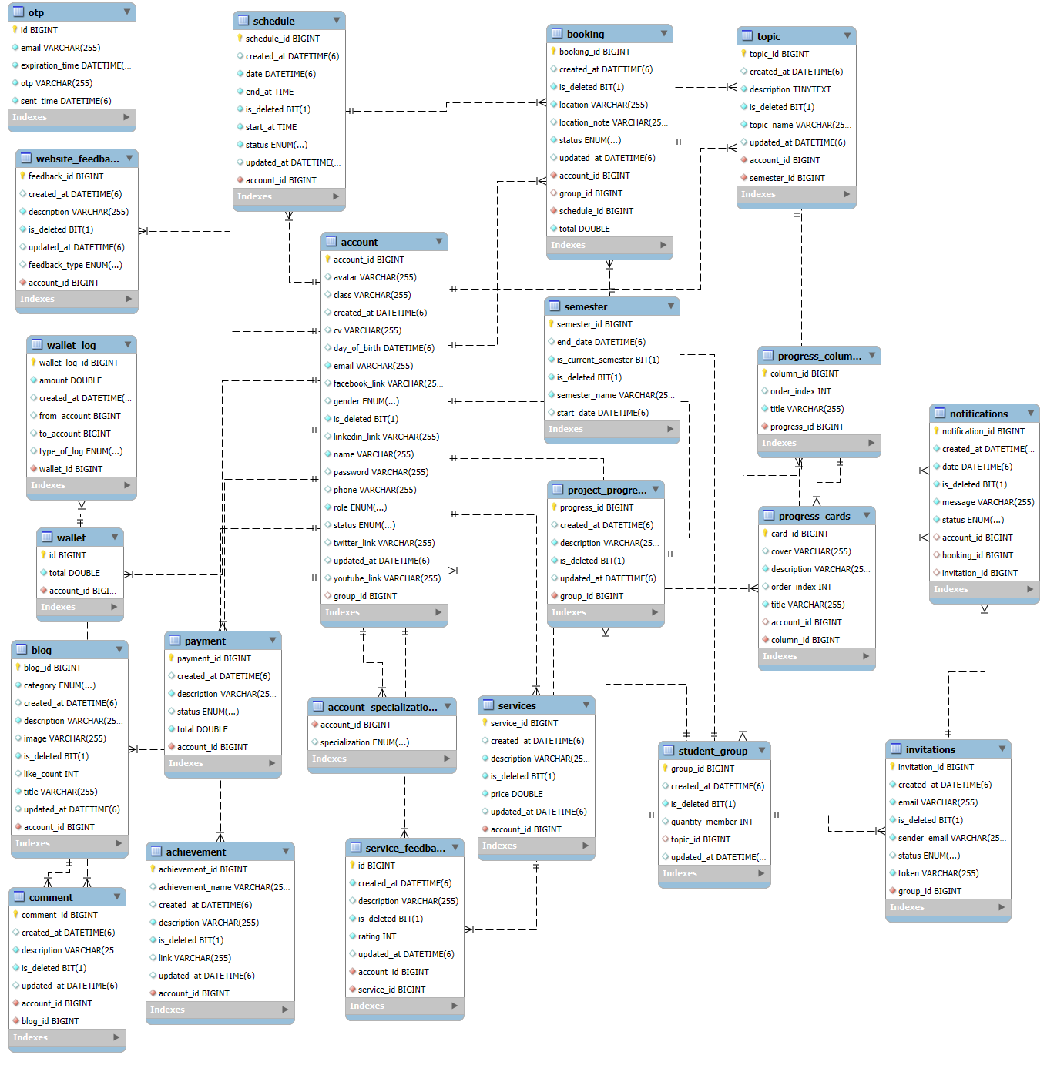

# **Usecase Diagram**

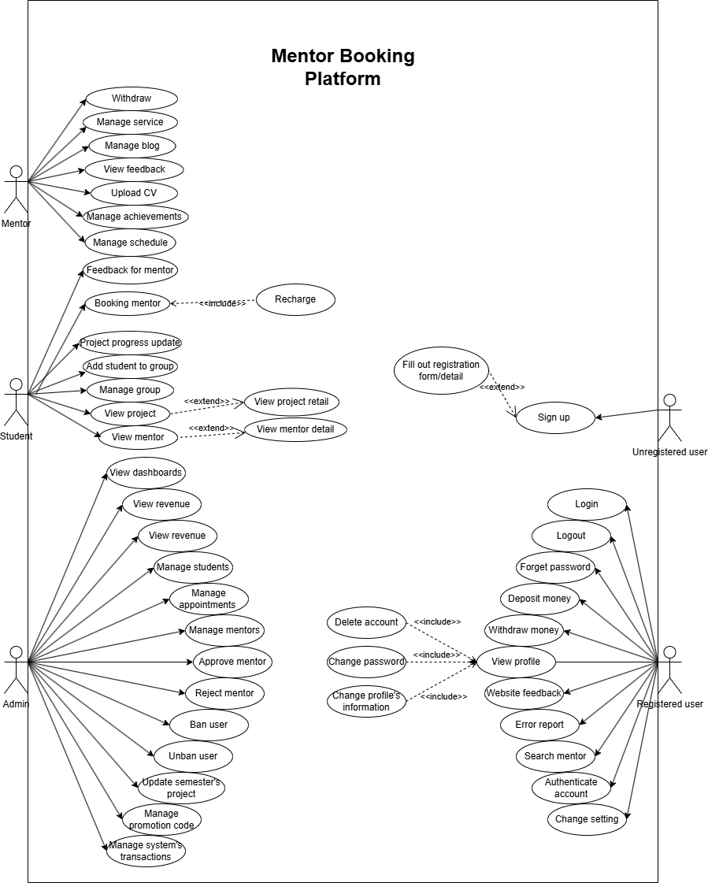

# **System Overview Diagram**

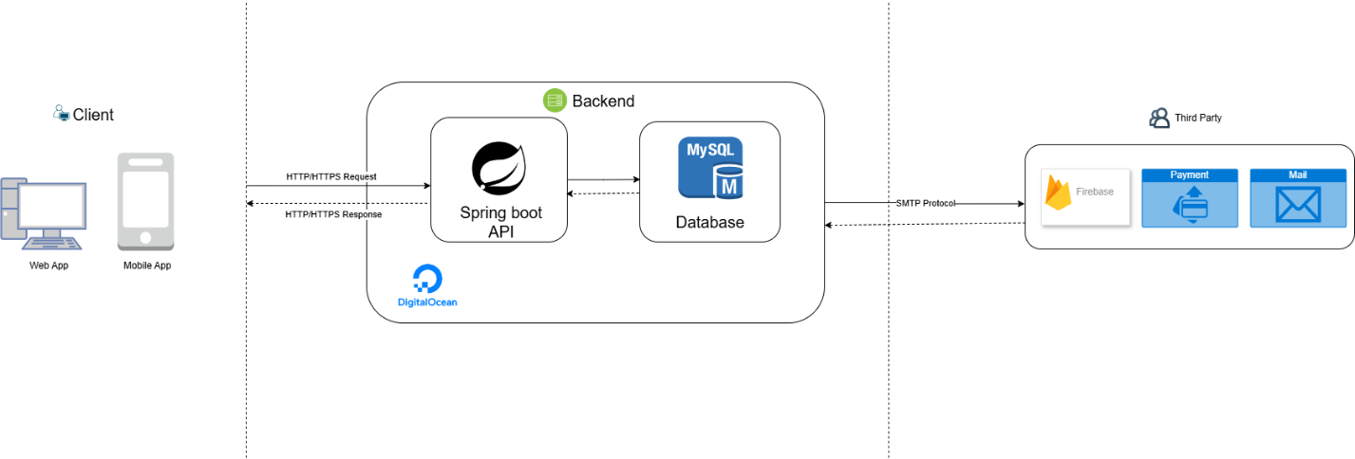

# **Activity Diagram**

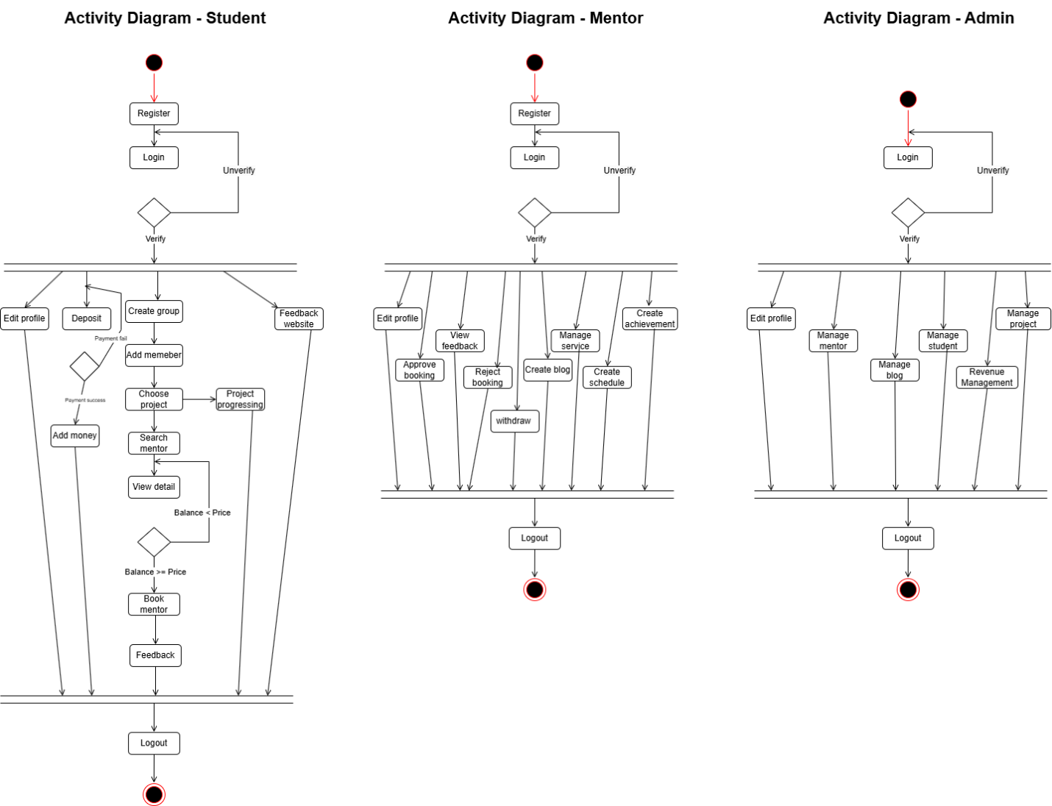

# **Sequence Diagram**

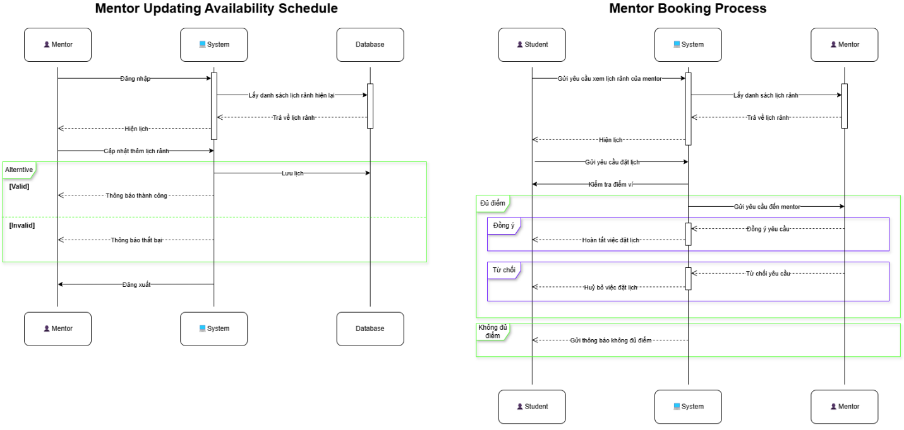

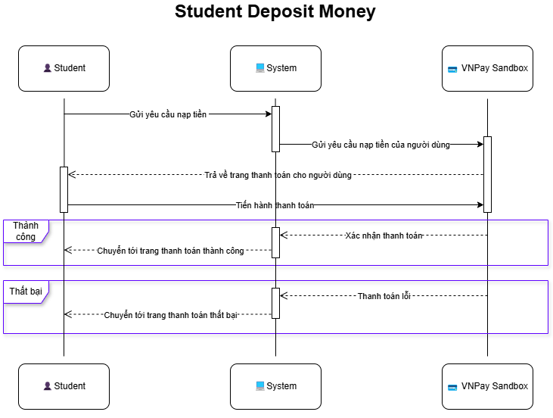

# **State Diagram**

